1.INTRODUCTION

* 1. OVERVIEW

Unlocking insights into the Global Air Transportation Network is the analysis of the dataset of information on airports, airlines and their routes.

This can be achieved with the help of Tableau . Using Tableau we can come to an conclusion for any sort of problems in any of the business field.

It contains information such as names, cities, countries, codes(IATA and ICAO) longitudes, latitudes, and altitudes of airports across the world with detailed time zone and daylight saving time data.

Additionally, this includes information about airlines including their ID’s name aliases ,IATA and ICAO codes , callsigns country of origin and active/inactive status.

Similarly, it also covers routes details such as airline sources to destination airports along with essential details like codeshare stakeholder if any stops required during this journey along with the type of aircraft being used for ha particular journey.

* 1. PURPOSE

This project helps us to identify the specific solution for any problems to make a business in a profitable manner.

2.PROBLEM DEFINITION AND DESIGN THINKING

2.1 EMPATHY MAP SCREENSHOT

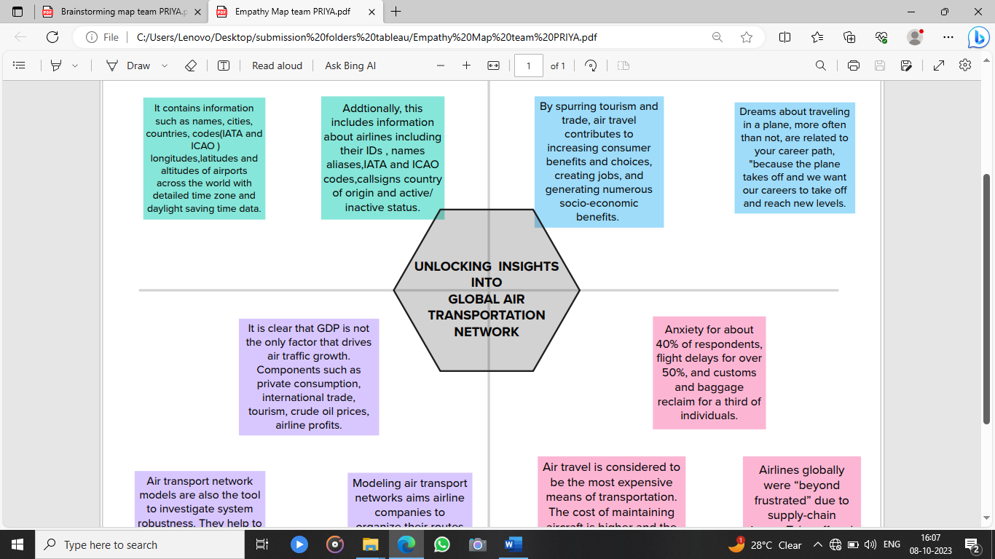

2.2 IDEATION AND BRAINSTORMING MAP SCREENSHOT